
;l

Foundations of Programming

Assignment No. : 4
PROBLEM STATEMENT: Write a C Program to calculate the salary of an employee given his basic pay (taken as input from the user). Calculate gross salary of employee. Let HRA be 10 % of basic pay and TA be 5% of basic pay. Let employees pay professional tax as 2% of total salary. Calculate net salary payable after deductions.

OBJECTIVE:

- To understand the importance of flowchart for any programming model.
- To learn simple flowchart symbols and arrows to define relationships.
- To understand and develop visual representations of flow of data.

THEORY:
- Define Algorithm
ans. An algorithm is a step-by-step procedure used to solve a specific problem or complete a task. It consists of a finite number of clear and well-defined instructions that take some input, process it logically, and produce an output. An algorithm must be simple, unambiguous, and complete within a limited number of steps. It forms the foundation of computer programming and helps in solving problems efficiently and systematically.
- What are the different characteristics of an algorithm.
Ans. An algorithm has the following important characteristics:
1️⃣ Input-An algorithm should accept zero or more inputs.
2️⃣ Output-It should produce at least one output as a result.
3️⃣ Definiteness-Each step must be clear, precise, and unambiguous.
4️⃣ Finiteness-The algorithm must terminate after a finite number of steps.
5️⃣ Effectiveness-Each instruction should be simple and feasible to execute in a finite amount of time.
6️⃣ Generality-It should solve all valid inputs of the problem, not just a specific case.

PLATFORM: Linux
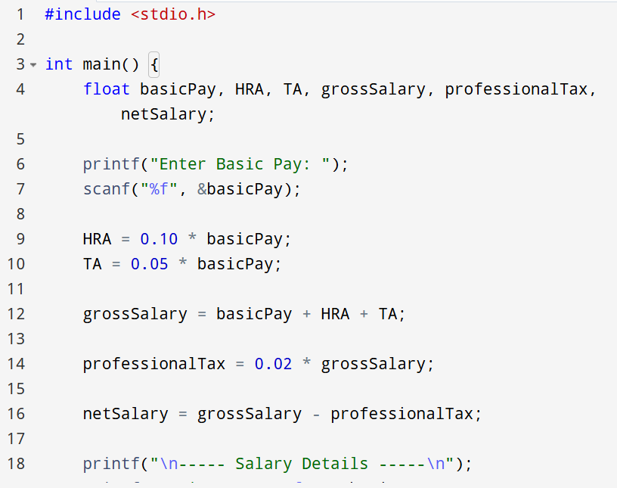
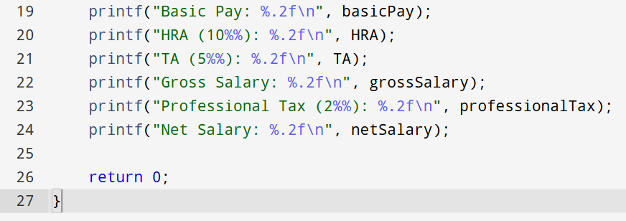

INPUT:
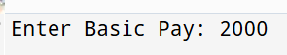
OUTPUT:
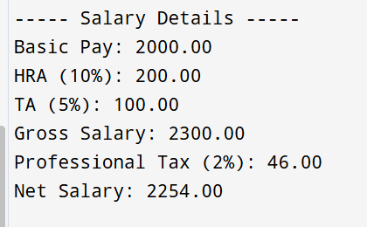

CONCLUSION: Thus, we have learned to write algorithms and to draw its representation in terms of flowchart.

FAQs:
- Describe various symbols and their use in flowchart.

- Difference between Algorithm and Flowchart.

Flowchart
